**My process of Implementing a slide show:**

To begin, I added 3 containers to my index.html file, each one assigned an image and an ID. I added “fade” into the ID as this will help with the javascript and CSS styling:

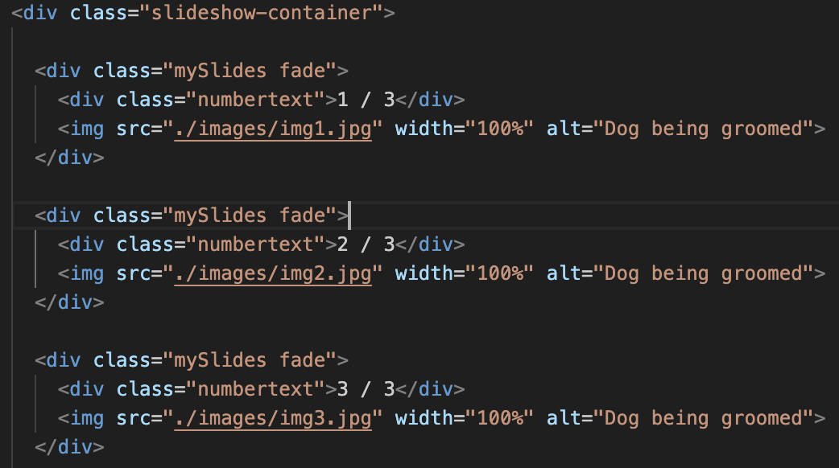

After some thinking on how I wanted the slideshow to look, I decided I wanted arrows on either side of the container so visitors to the website would be able to skip images. I have also previously seen slideshows where there are dots underneath that highlight depending on what photo the slideshow is on. This is also something I wanted to implement. I then added in the next and prev classes with “onclick” so as these could be called within my JS file. This is a similar case for the “dot” classes:

I then moved onto my JS file to implement the script for my slideshow. The below code retrieves all slides from the html and all dot classes. It hides all slides and removes the active class from the dots. slideIndex moves to the next slide and highlights the current dot in relation to the slide number.

I then added in the following Autoplay function which changes slides every 3 seconds. The plusSlides allows users to click the next or previous buttons to navigate to a particular image.

Autoplay is stopped when these buttons are used. The dots can also be used to navigate to a particular photo

